KINETIC PAINTING

VR APPLICATION

“Every artist was first an amateur” Ralph Waldo Emerson

STUDENTS:
Roee Peleg

Yonatan Sherwin

SUPERVISORS:
Yaron Honen

Boaz Sternfeld

TABLE OF CONTENTS:

Background

Systems & Technologies

Overview

Challenges

Future work

Screenshots

BACKGROUND

Kinetic Painting is a unique VR application for drawing using hand gestures.

With no physical controllers at all, you’ll be able to choose between two main painting methods.

The user will be able to start the painting, erase it, change the level, change the colors of the paint, and even create some special effects.

Using the leap motion controller, you can control and activate the game with various of hand gestures.

SYSTEMS & TECHNOLOGIES

The game was developed using Unity - a cross-platform game engine that can be used to create both three-dimensional and twodimensional games as well as simulations for desktops and laptops, home consoles, smart TVs, and mobile devices - Unity is scripted with C# in visual studio.

The application required the following equipment:

Oculus Rift headset
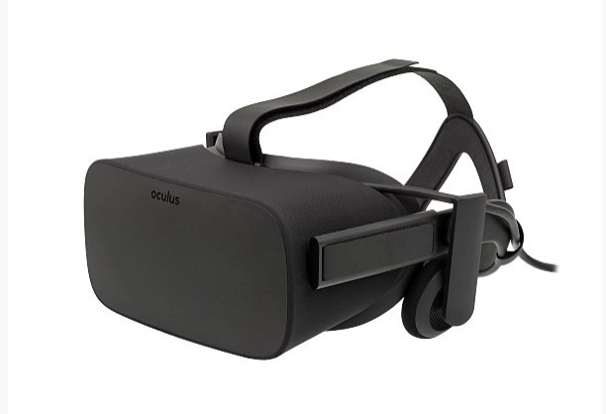
The Oculus Rift is a virtual reality headset developed and manufactured by Oculus VR, a division of Facebook Inc., released on March 28, 2016.

Oculus sensor

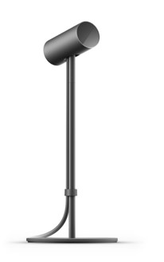
Oculus Sensor tracks constellations of IR LEDs to translate your movements in VR.
Leap Motion

Infra-red hand tracking device
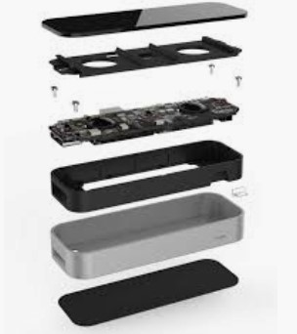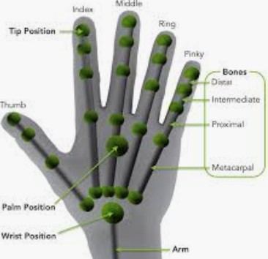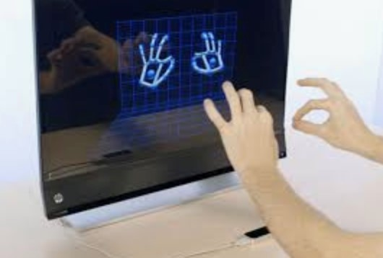
Two hands

(well, one is enough for most of the gestures)

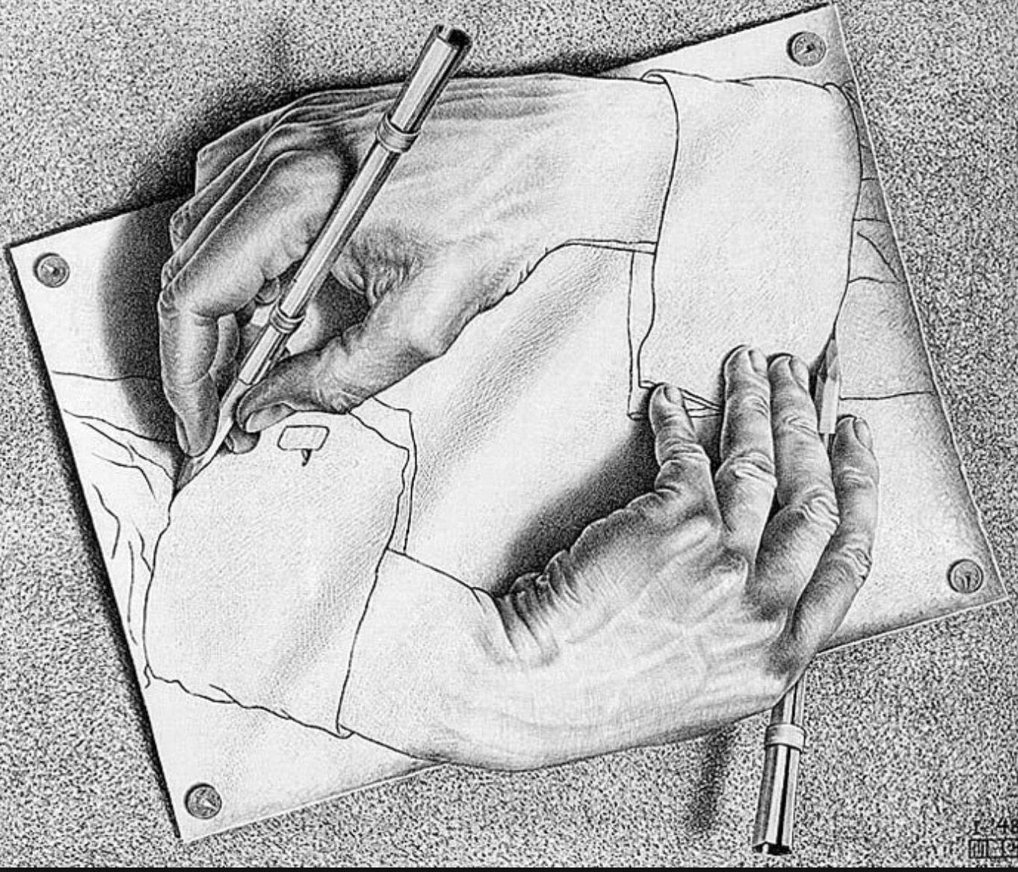

OVERVIEW

The game consists of 4 scenes:
- Intro
- Draw Line
- Create Trail
- Fire Trail

The game environment is a working room with a desktop.

Intro:

The intro scene allows the user to choose the next scene.
There is an example of the desired gesture for each scene.
The gesture for choosing the scene is the same gesture we are using on the scene itself – pinch gesture will choose the “draw line” scene, and a brush gesture (only the finger extended) will choose the “create trail” scene.

Draw Line:

In this scene the user will be able to paint with permanent lines.
When the user starts pinching, the line will start, until the user releases the pinch.
It is possible to paint with both hands simultaneously.
To delete the paint, you can set your thumb to the right, which will make the paint “fall” and disappear.

Create Trail:

In this scene your finger is used as a brush to create a trail. In this scene we've entered a special gesture - clapping your hands. This gesture will make the colored trail disappear, and will start a fire trail. It is also possible to change the color of the trail with a color slide bar.
You will also be able to return to the intro scene pointing your thumb to the left.

Fire Trail:

We’ve added a special gesture for setting the fire – hands clapping.
In this scene, the gestures are same as the once on the “create trail” scene, except for the fact that the trail is no more just a colored trail, but a fire, created using the Unity particles engine.

DEEP DIVE – THE CLAPPING GESTURE

From all of our gestures, the clapping gestures was the most complicated one. In contrast to all the other gestures, there were simply no examples on the web for creating this gesture.
We made this gesture as follows:

- We’ve made sure both hands are in the frame
- We’ve checked the hands are facing each other with the appropriate angle
- We’ve checked all the fingers are extended
- We’ve calculated the velocity using the palms positions to make sure the it is really a clap, and not just putting our hands together.

CHALLENGES

Our major difficulty was to handle all the new tools and environment. We weren’t familiar with the Unity editor before this project, and not to any type of VR programming.

It also took us a lot of time to understand how to integrate all the tools. Even after we understood how to use the Leap Motion, the Occulus Rift, and Unity editor, the integration wasn’t simple at all.

FUTURE WORK

Possible next features for this project:

- Change the size of the trails and lines.

- Delete only one line at time

- Adding some more gestures and painting modes

SCREENSHOTS
