VRchitect
Supervisor:Hanon Yaron, Sela Matan, Boaz Sternfeld
Students: Frenkel Eduard & Salevich Alexander
(234329)
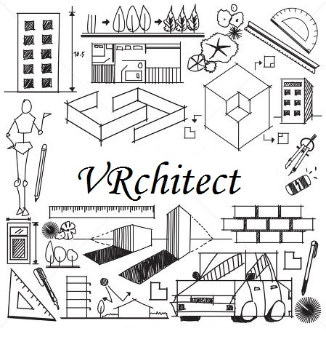

Problem Definition and Motivation
Main Problem:
Nowadays there are many interior design tools for house / office design, yet the existing tools provide only abstract representation of the final design.
The tools allow to render a designed scene which can be shown to a customer, yet they do not pass a real experience of presence in a room, which might be ineffective in a design process and lead to unwanted final result.
Goal:
Our project's goal is to overcome this challenge and allow a user to experience a sense of presence in a room while designing it.
We intend to build a designing tool using virtual reality which will allow to design a room space while being present inside a virtual room;
The tool will allow the user to design a room interior and be able to experience his work product at the same time.
Our solution will allow to design better suited environment for the customer by letting the designer the ability to show the customer the final design and get his feedback.

Solution-Features & background

Platform :
- Hardware platform: HTC vive
- Software platform: Unity 3D, VRTK toolkit, Mono develop IDE
GUI description:
The GUI will consist of following features:
  - The application consists of two modes: room choosing mode, in-room edit mode (explained further afterwards).
  - HTC controller radial menus:
    - Right controller - Main menu - will allow to choose a general action (scaling / moving / rotating / rotating in space/ choose room or item)
    - Left controller - Sub menu - will be used for specific action after a main menu option was chosen
  - Pointing laser – in order to be able to control models which are not reachable due to HTC vive space restrictions, a pointing laser is rendered in the VR environment to provide the ability of modeling big room spaces.
  - Main menu that allows switching between rooms, open item menu, delete models, enable/disable tooltips, exit.
  - Model Choosing menu – will bring up a scrollable menu with furniture / design features to place in the modeling environment. The menu will be controlled by the HTC controllers, radial menus and pointing laser.

Vrchitect Modes
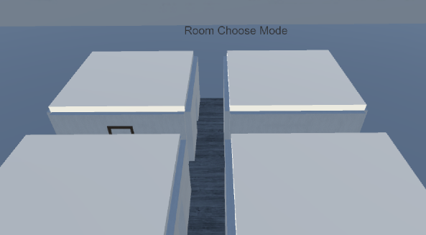
Room Choose Mode:
This mode allows the user to move in
the workspace and choose a room to design.
The user can point the laser tip to the rooms
ceiling to reveal the content of the room,
and press the trigger to enter the room.

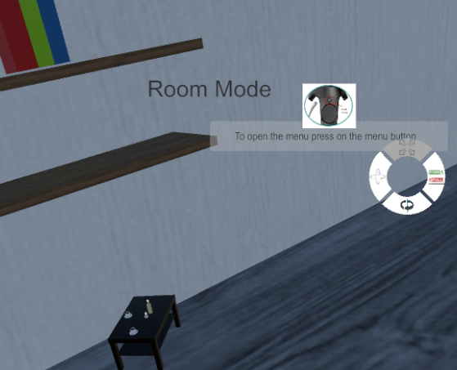
In Room Mode:
This mode is triggered by entering a room
can manipulate (scale, rotate, etc.) the
existing models and also add/delete new
models from the item menu.
*note: in both modes tips can be disabled and
the controllers provide different behavior.

Controller Radial and Main Menus
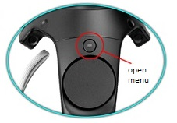
Main Menu:
This menu is available from all modes ,by pressing the
Menu button on the controller.
Choosing An option from this menu is done by
pointing the Laser tip to the right Cube and
pressing the trigger.
  - Add model-This option will open a new menu, a scrollable item menu (explained afterwards).
  - Enable/Disable ToolTips-The icon will change accordingly.
  - Delete model-allows you to point the laser to a model,
by pressing the trigger the model will disappear
*when choosing this option the lasers color will become red.
  - Room choose return- this option is used to exit the room to the
initial view (above the rooms).
  - Exit-quit the application.

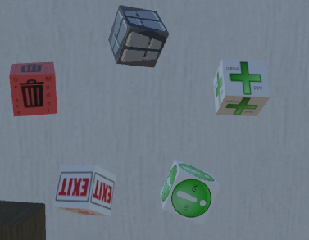

Controller Radial and Main Menus
Controller Radial Menu:
This menu is available from all modes ,by hovering over the controllers touchpad.
Different options are provided in different modes/states of the app:

Move in work space- room choose mode. | 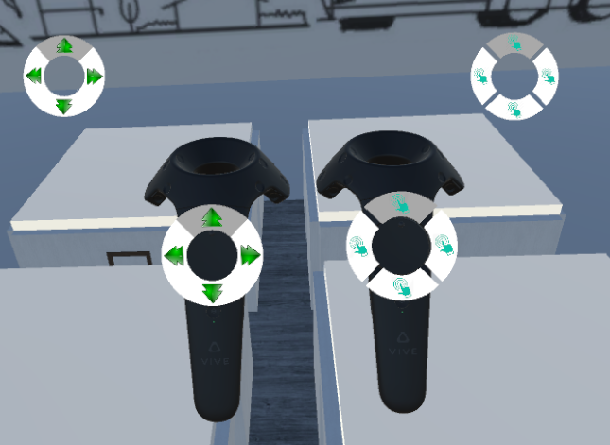 | Scroll menu item and choosing an item to instance in the room-in room mode. | 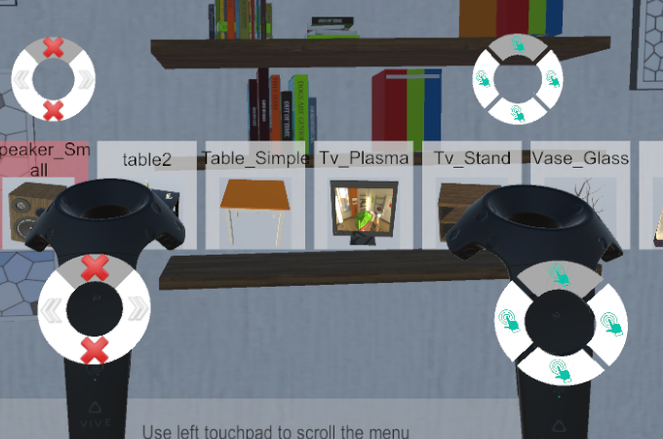
Scaling models-Enlarge / Shrink the model in room mode. | 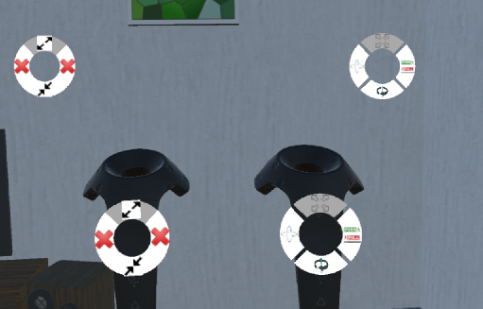 | Push/Pull models-Push / Pull the model in room mode. | 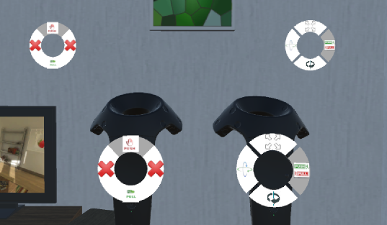
Rotation of models-Rotate the model on X/Y/Z axis in room mode. | 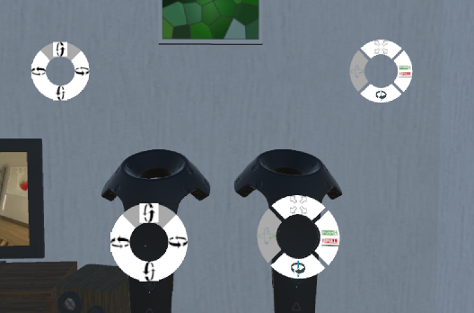 | Rotation of the room around its  center-in room mode. | 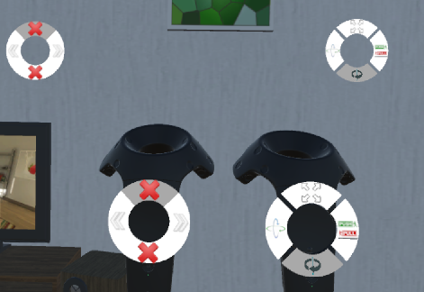

Controller Radial and Main Menus

Scrollable Item Menu:
This menu is available from in room mode, by choosing the
Add Model cube from the main menu.
The user can scroll the menu with the left
controller as shown in Controller menus slide.
by pointing the laser at the desired model and pressing trigger the model will
appear in front of the controller, already attached to the pointer tip ready to
be manipulated.

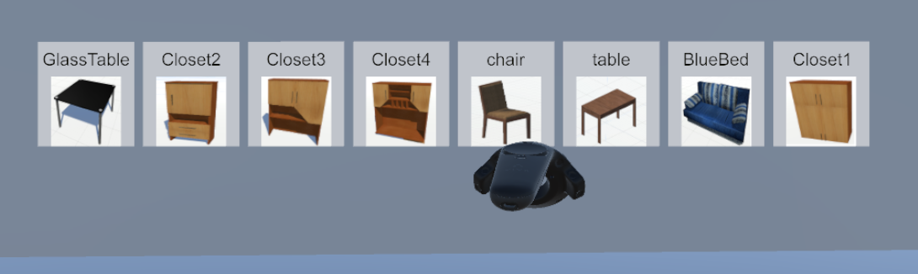

More Features

Shadow grid - when an item is chosen by the controllers laser, there was no way
to know exactly where it is in space, meaning will it collide or fall if released?
How can we put it exactly where we want to?
We needed a tool to help the user design accurately, therefore we developed
the Shadow Grid feature.
By using ray cast on one layer:

We ray cast over the item to encounter which parts collide with other models and which collide with the floor upon “landing” (red arrows in the scheme), and draw a grid (green in the scheme) on the surfaces that the shadow of the item intersect with, therefore allowing the user to know exactly where the item is relatively to other items and space.
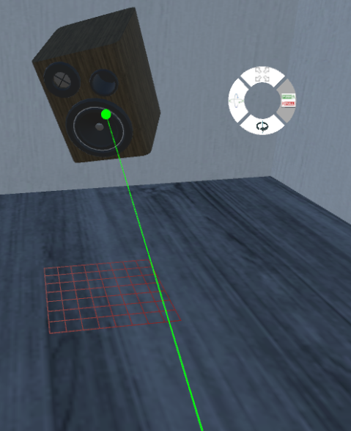
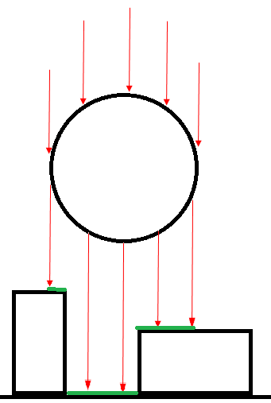

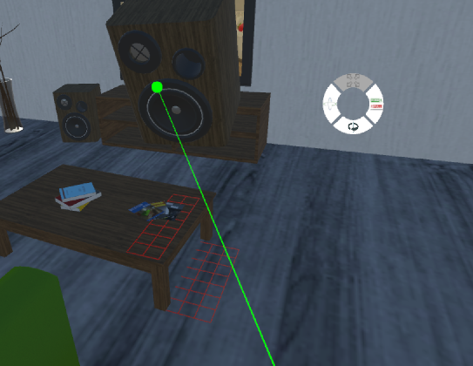

More Features

ToolTips
Since the app is very technical and multi-optional, we provided tips
in order to help the user to understand the features provided and how to use them.
The tips change from mode to mode and from menu to menu according to the
options available, predicting possible behavior or expected actions from the user.
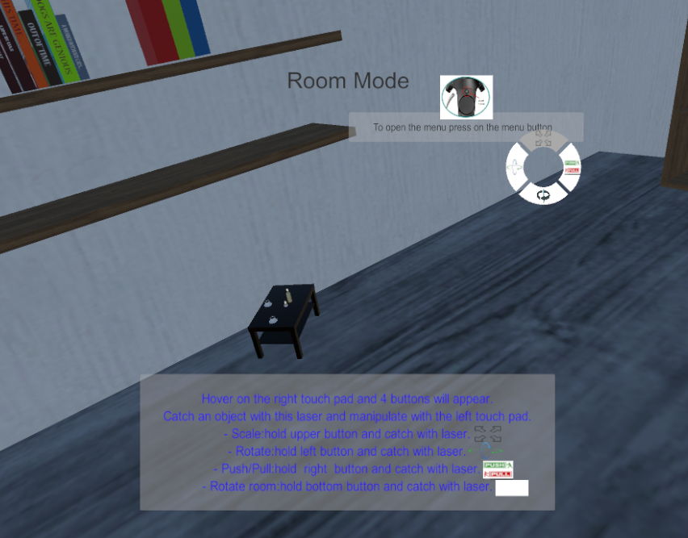
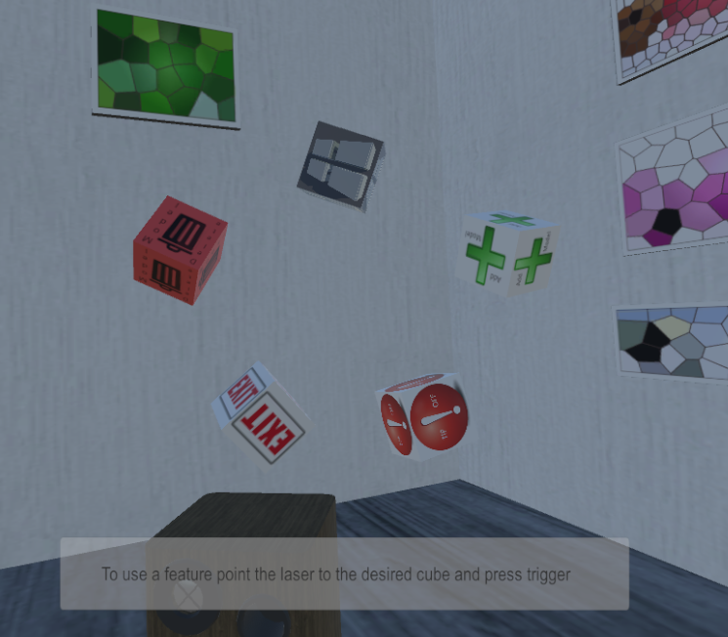
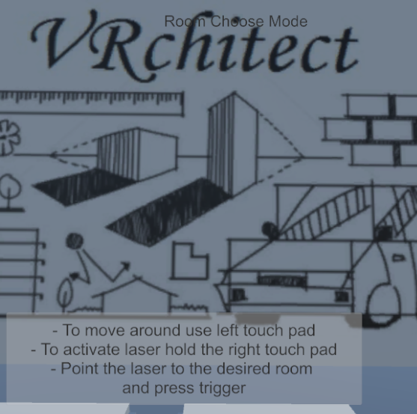

Improvements Ideas

The following ideas might be implemented as part of future projects:
  - Expand the menus: Allowing to change the models’ texture / material.
  - Loading a real environment by scanning a real room space via 'Tango' interface
  - Serialization of the designed environment with the ability to save / load a scene
  - Reshaping (or creating from scratch) the provided design environments

External Links

- Website: https://sloovi1990.wixsite.com/vrchitect
- Git repository: https://github.com/sloovi90/VRchitect
- Video link:https://www.youtube.com/watch?v=02-eBrFMSQ8

