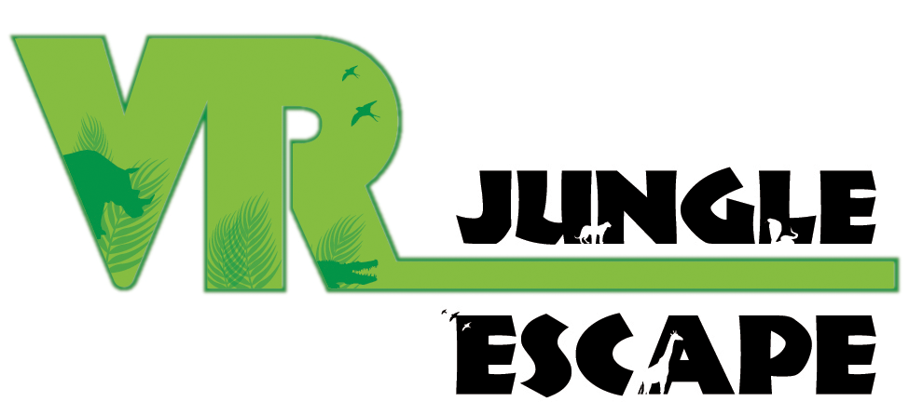

Jungle Escape VR
STUDENTS
Tal Albo
Dan Simah
Lorella Matathia

SUPERVISORS
Boaz Sterenfeld
Yaron Honen

Table of Content

Abstract 3
Introduction 4
Develop Environment 5
Application Overview 6
Development Process 7
Manual 9
Sight for the Future 15

Abstract

As part of our B. Sc. in Computers Science, we were curious about the Virtual Reality world. As we tried for the first time the Oculus technology, we immediately thought about the possibilities for a VR RPG game, and the amazing games that could possibly come.

We created an ‘Escape Room’-like game with the emphasis of creating generic building blocks for future VR applications. We truly hope that this game will inspire the next generation of RPG gaming and help with the development of VR application.

Furthermore, we would like to thank to the GIP & CGGC staff, and especially to Boaz Sterenfeld and Yaron Honen.

Introduction

‘Jungle Escape VR’ is a VR game with a storyline of an Escape Room game which takes the experience of an Escape Room game to the Virtual Reality. With taking this experience to the VR world we tried to give a feeling of what future gaming and simulators will look like, and doing this while creating components that could be used in many VR applications in the future, and all of this while maximizing the user experience of playing an actual Escape Room game which is exciting and challenging.

The main components:
- A Menu:
  - Activated by hand gesture
  - Easily configured
  - Intuitively operated
- Map
- Inventory:
  - Easily configured
  - Insert and remove items intuitively
- Tips menu
- A linear progressed storyline

Develop Environment

Unity
A cross-platform game engine that can be used to create both three-dimensional and two-dimensional games, as well as simulations for desktops and laptops, home consoles, smart televisions, and mobile devices. Unity is scripted with C# in Visual Studio.
Required Equipment:
Oculus Headset: The Oculus Headset is a virtual reality headset. The headset uses tracking technology, allowing the user to move in 3D space and use motion-tracked controllers to interact with the environment.
Oculus Controllers: Each controller has inputs. The only buttons that are used are the grip and the joystick.

Application Overview

This chapter is a summarized manual for operating the menu we built and used in our application. The complete manual is one of the next chapters.
Open the Menu
For opening the menu put your left hand faced up (while holding the controller of course) and double-click the x button on the left controller.

Close the Menu
For Closing the Menu, you can either flip you left hand so it won’t be faced up anymore or you can double-click the x button on the left controller.

Navigating inside the Menu
For Navigating inside the Menu, use the Thumbstick on the left controller. Pointing the Thumbstick to the left will navigate to the left, same for pointing the analog to the right. You can navigate between a Map tab, a Tips tab and an Inventory tab.

Grabbing objects
Grabbing and holding object is done with the Grip Button while the hand is touching the object.

Using object from the Inventory
While navigated to the Inventory tab inside the Menu, a blackened object means it is not in the inventory. An object which is not blackened can be clicked using the Trigger button on the right controller and the object will appear next to the hand.

Putting an object inside the Inventory
When holding an object which can be added to the Inventory (the object has a blackened spot inside the Inventory), hold the object in your right hand, open the Menu using your left hand, and then drop the object in the middle of the Menu. This will make the object disappear from the air and appear in the Inventory.

When the application starts, we are in the jungle in front of a tutorial guide. This tutorial guides on how to operate and use the menu which is our main component.

Development Process

When we came across with the idea of having a final project in the CGGC & GIP laboratory, we immediately thought of an amazing Jungle in a VR world in which we want to wander and see the amazing features the VR world opens for us. We decided to develop an Escape Room kind of game in a jungle world, and in the process develop generic tools for VR that can be used in future VR applications.
In the beginning, we had a vision of a Menu that will appear on your hand via some hand gesture, will be intuitive and easy to use as seen in Sci-Fi movies. We started by designing the Menu so it will be easily deployed in different environments, intuitive and pretty. First, we thought of a menu that will be placed on the wrist like a watch, but we encountered many technical problems that occur from using one hand on the other. Because of that we decided that the menu will be displayed above the hand, and so we designed a menu that will be displayed above the hand and an animation for the activation of the menu.
The menu was created so that it would be opened by a hand gesture. We tried to think of a hand gesture which we will be able to recognize, would be easy and intuitive for opening the menu and on top of that wouldn’t be a gesture that a player would do by accident in a normal use of the application. After some experiments we defined a gesture of a rotation motion of the left controller in which the left hand finishes face up. When this hand gesture is used, the Menu is opened (using an animation of a spin move) above the hand. The menu could be rotated (to switch between tabs) by dragging the menu in a rotary motion with the right hand (like switching a page in a book).
When we showed the menu to our supervisors Boaz Sterenfeld and Yaron Honen they advised us to change the gestures of opening the menu and rotating it using the buttons of the controllers instead of the hand gestures so it would be easier to do, so we changed it by their advice (with further explanation of the operations in the manual).
So, as we had a menu that we could open, close and rotate, we continued the design of each part of the menu. The menu can be divided into as much parts (or “tabs”) as needed, we decided to work with 3 tabs for the game we were designing. The tabs we decided to create are “Tips”, “Map” and “Inventory”. The Map is actually a view from above of the jungle with big dots on each point of interest in the map which we want to see. The Tips tab is divided so the tips of the game appears small on the side of the tips tab with the current relevant tip shown clearly at the middle of the tab. The Inventory tab is divided into 6 slots (configurable), each slot is for an item that exists in the jungle. For an item to appear in the Inventory it needs to be found in the jungle, grabbed and dropped inside the menu. An item could be used from the Inventory by clicking on its slot in the Inventory with the right hand.
After we finished with the Menu, we searched for assets we wanted to use for the Jungle. We’ve gathered some free assets from X and combined them all together to create a cool jungle. We added a script to the jungle so we could move in the jungle with the right Thumbstick. And to finish it all we designed a storyline for the game and put all the pieces together to make it all work.

Manual

This chapter will explain, step by step, how to use our application:
First here is an explanation about the controller’s buttons:
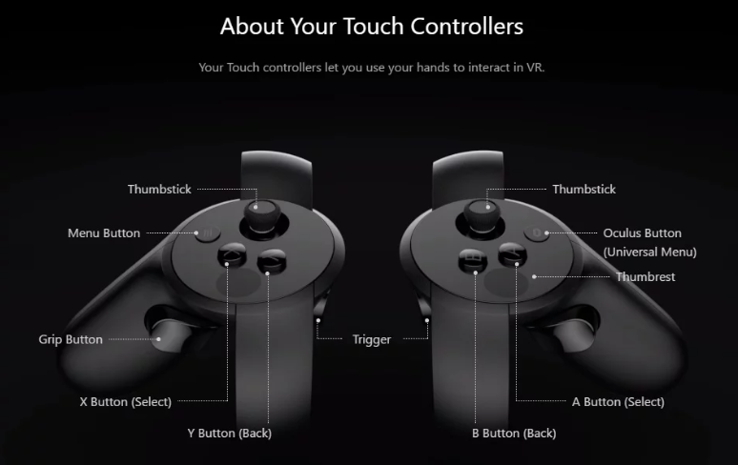

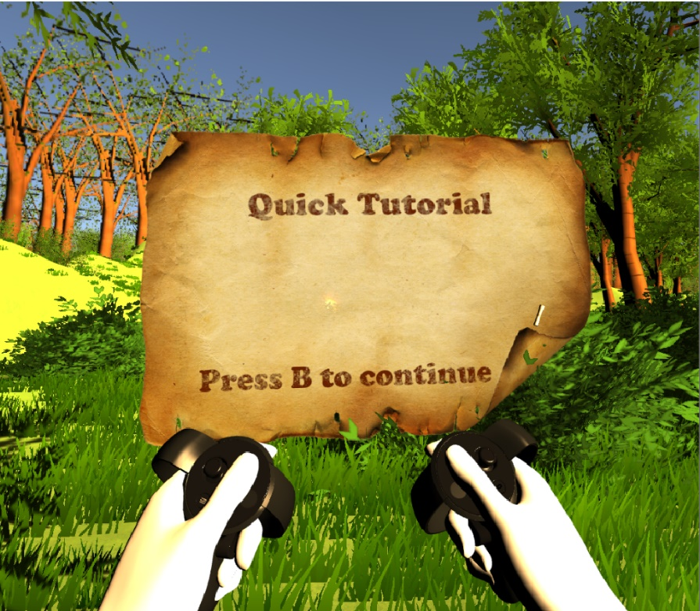 |  |  | Start here!  This is the starting point of the game. There is a tutorial to start the game which explains how to operate the menu:
Open the Menu  To open the menu put your left hand faced up and double click the X button. |  |  |  | 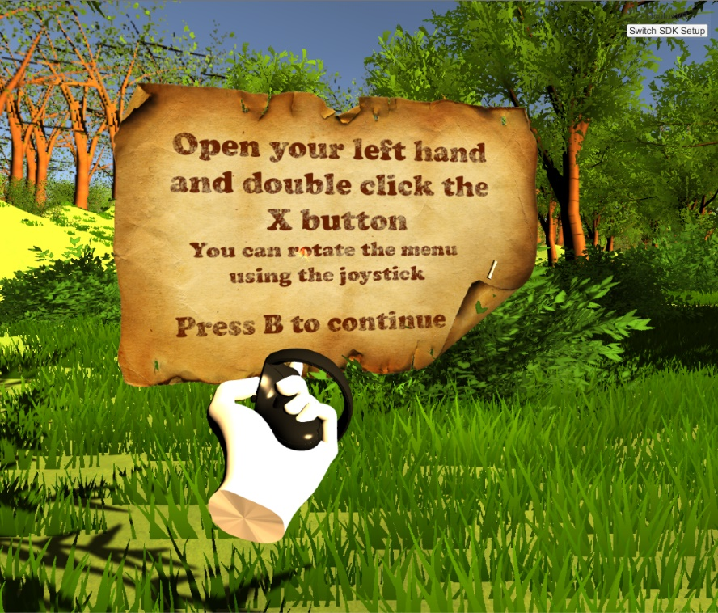
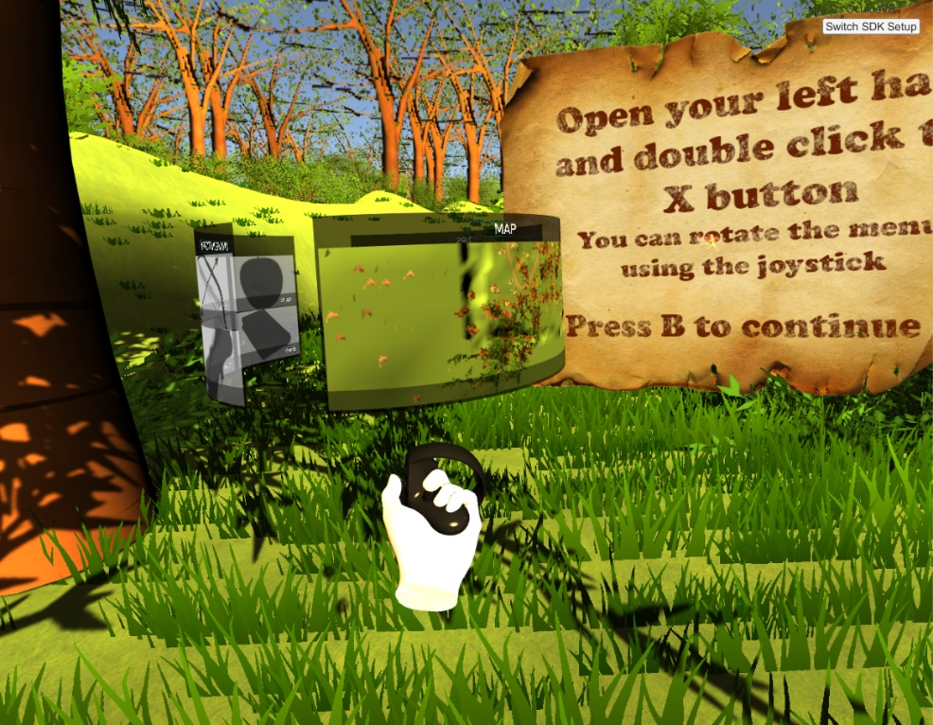 |  |  | The menu when it’s open.
The Inventory  The menu rotated to the inventory tab. |  |  |  | 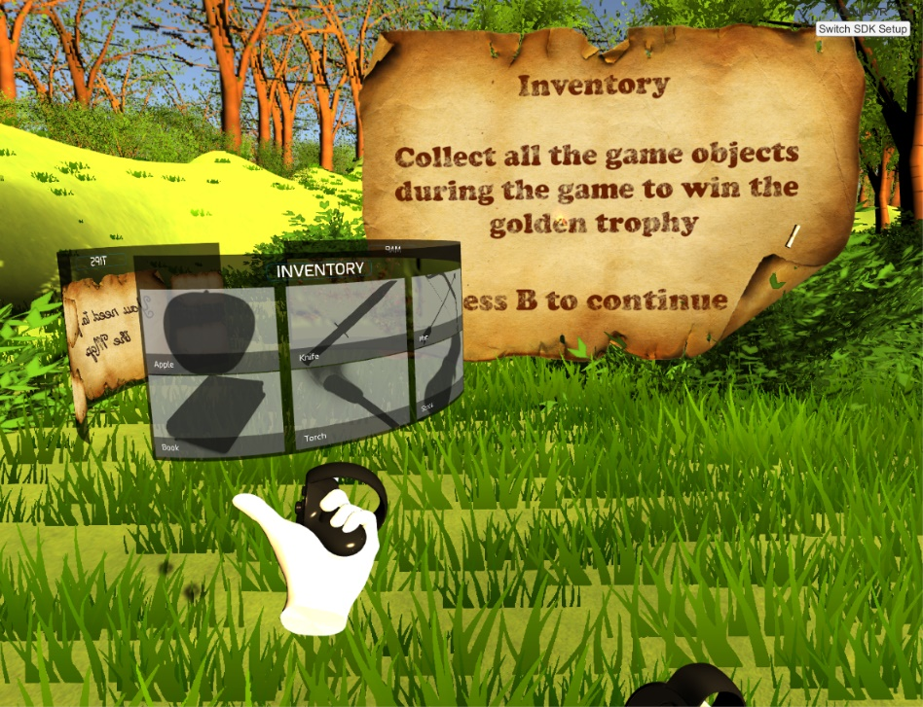
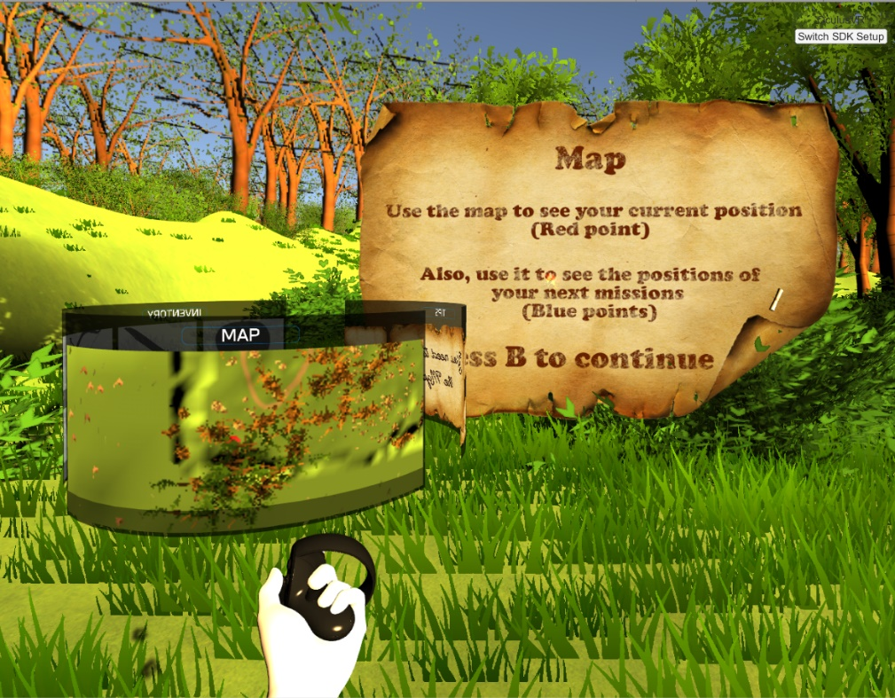 |  |  | The Map  The menu rotated to the map tab.
The Tips  The menu rotated to the tips tab. |  |  |  | 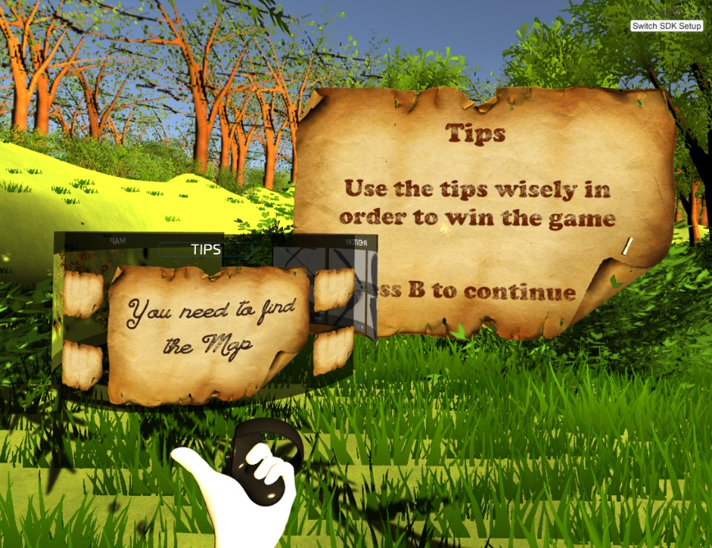
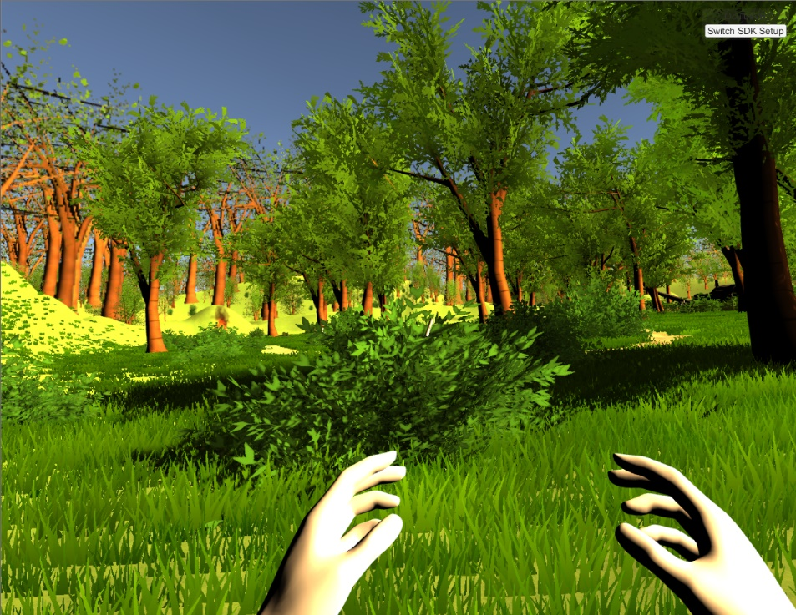 |  |  | Beginning of the game  Now the tutorial is finished, and the game begins. You can walk around the jungle, collect items for the inventory, and solve how to find the treasure.  The game is finished by finding the treasure.
Find the torch  The torch is located in the crashed plane,  You can grab it by holding the grip button while  touching the torch (either hand) |  |  |  | 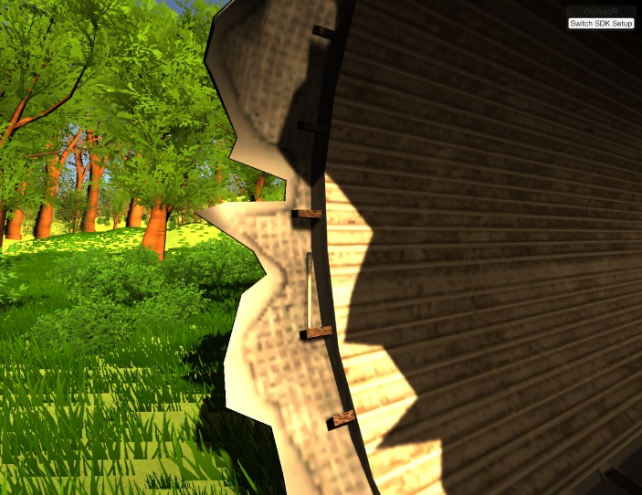
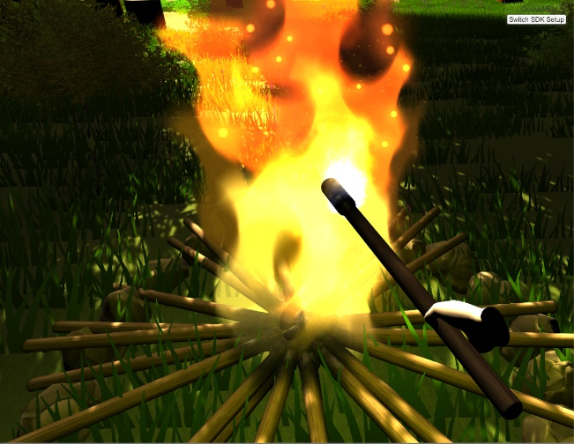 | Light the torch  You can light the torch using the bonfire located withing the jungle
Solve the riddle  Take the lightened torch to the crashed plane to see  The riddle and solve it |  |  |  |  | 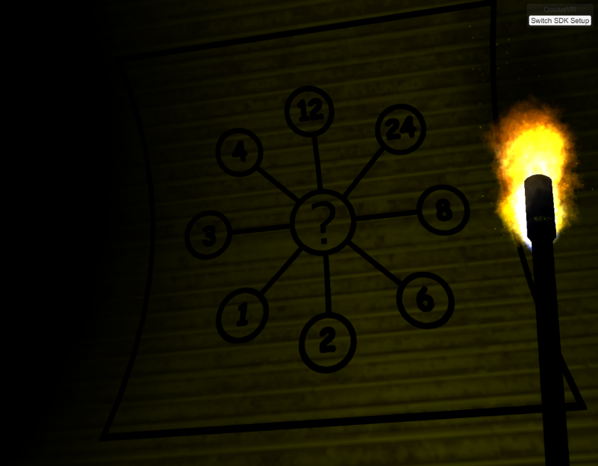
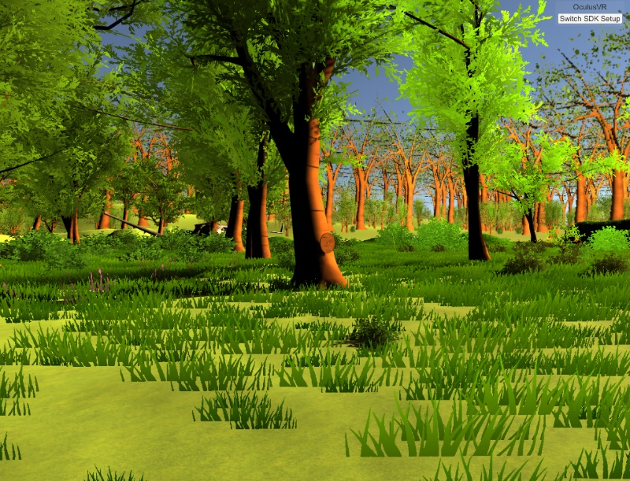 |  | Find the tree that needs the answer  There is a special tree which has a wheel on it. On that wheel you need to set the answer of the riddle
Set the answer  Rotate the wheel clockwise until it is set on the answer (the answer is 24). |  |  |  |  | 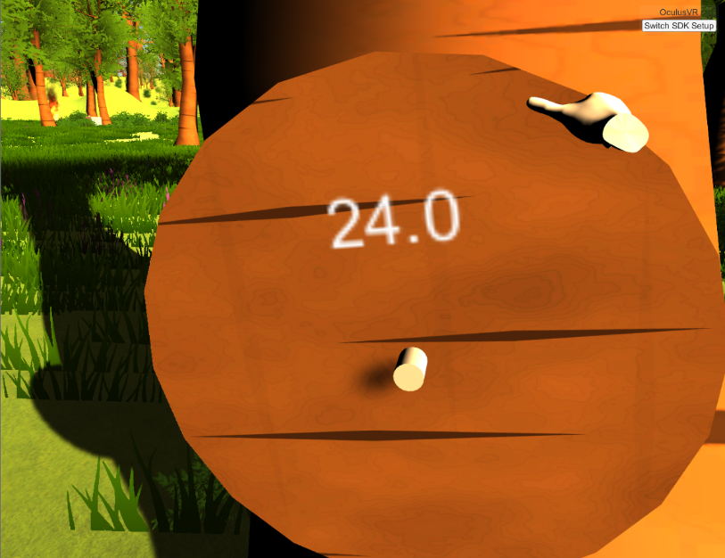
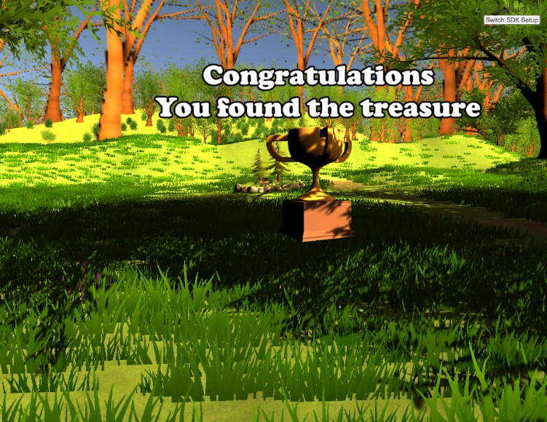 |  | Find the treasure  If you finished the riddle than the treasure appeared in the jungle, walking to it will set fireworks.
Find all the hidden items  There are 6 hidden items in the jungle, if you’ll  find all of them you’ll earn a trophy |  |  |  |  | 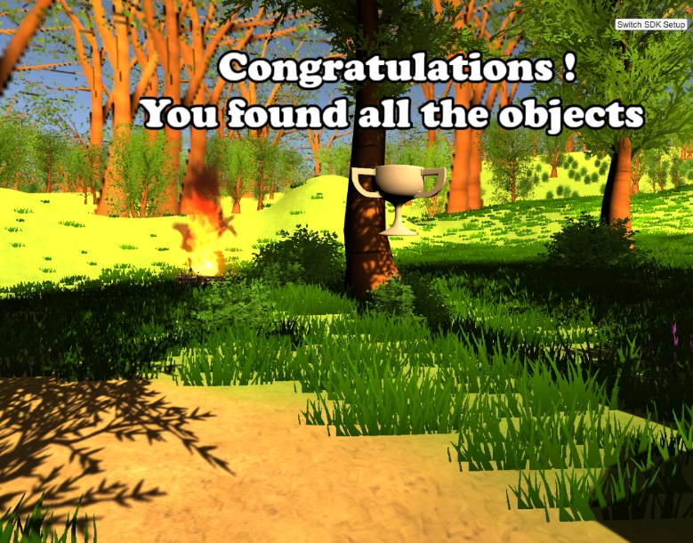

Sight for the Future

Unfortunately, this project has come to an end, and our work on it has to stop. If we could suggest some extensions and additions to the continuous project, we would recommend adding the following options:
- Upgrade the movement script so going up/down a hill will change the speed.
- Add more fun components so there could be more challenging missions in the game.
And we recommend taking the menu we’ve built – which we worked hard to create as generic as we could so it could be used in any kind of VR application – and use it!

en.wikipedia.org/wiki/Unity_(game_engine)

